Question 01 Create two different network 172.16.0.0/16 192.168.100.0/24 Create a route by adding a router and assigning a default gateway, so that they can communicate.

Sol.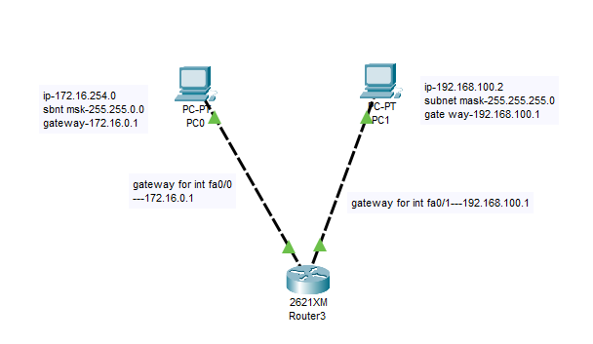

PDU RESULT-

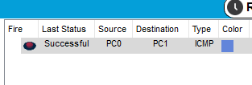

Question 02 Create 6 systems in the same subnet and isolate their communication via VLAN.

Sol.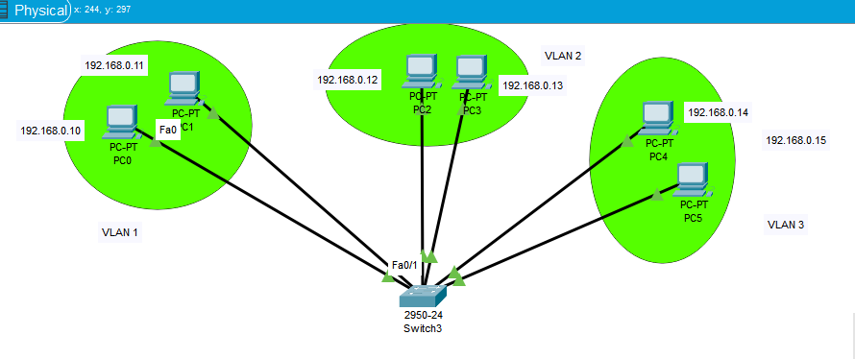

PDU RESULT- SUCCESSFUL FOR VLAN

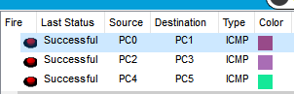

PDU RESULT FOR FAILED COMMUNICATION WHILE TRYING TO COMMUNICATE OTHER VLAN

